**Exercise - If group of actions**

In this exercise, you will apply some of the **If** actions available in order to identify the capabilities they offer.

1. Use a **Get Special Folder** action to retrieve the path to the desktop.
2. Check whether a folder named **Records** exists in the desktop. To do this, use the **If Folder Exists** action, and configure its input as follows:

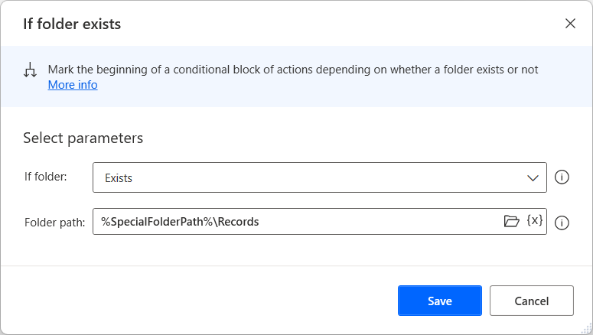

1. Inside the **If** block, add an **If File Exists** action to check if the **Expenses** Excel file exists inside the **Records** folder. Configure it as follows:

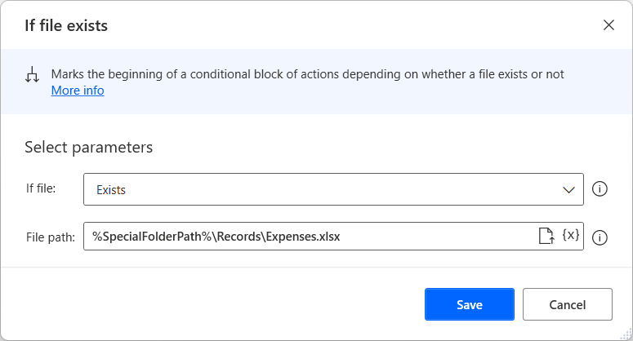

1. This will only run if the Folder exists. By this stage, your flow should look like this:

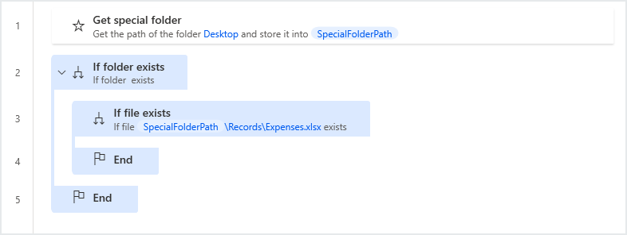

1. If the file exists, move it to the desktop folder using the **Move Files** action. Otherwise, the user should be notified; add an **Else** action inside the second if block, and a **Display Message** action to inform the user that the file has already been moved.
2. Finally, in case the folder itself does not exist, add an **Else** action inside the first **If** block, and a second **Display Message** action to inform the user that the **Records** folder does not exist:

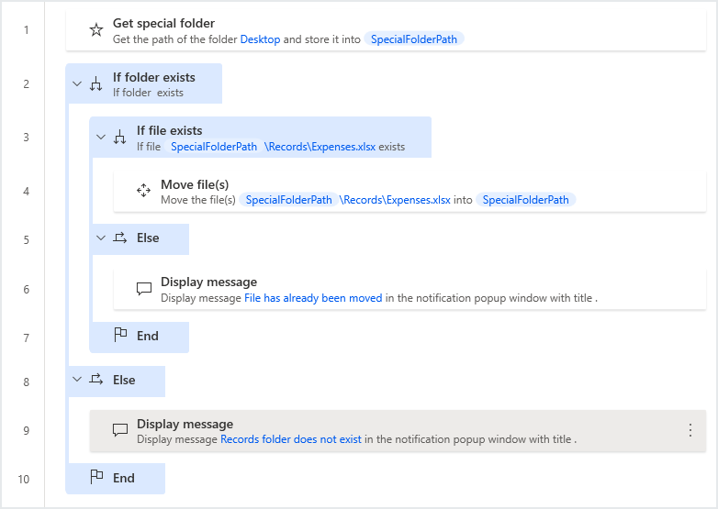

1. We suggest that you run the flow, trying different scenarios.

**The Switch group of actions**

The **Switch** group of actions is used when a flow's next steps depend on the value of a specific variable. Let’s clarify this with an example.

The following flow retrieves a list of all the files in the **Documents** folder, and produces a file count based on 3 types of filenames: those containing the word **Payments**, those containing the word **Employees**, and those containing the word **Schedule**. A message containing the file counts is then displayed on the screen for the user to review.

First, we will retrieve the path to the Documents folder, retrieve all the files inside, and initialize four variables to act as file counters:

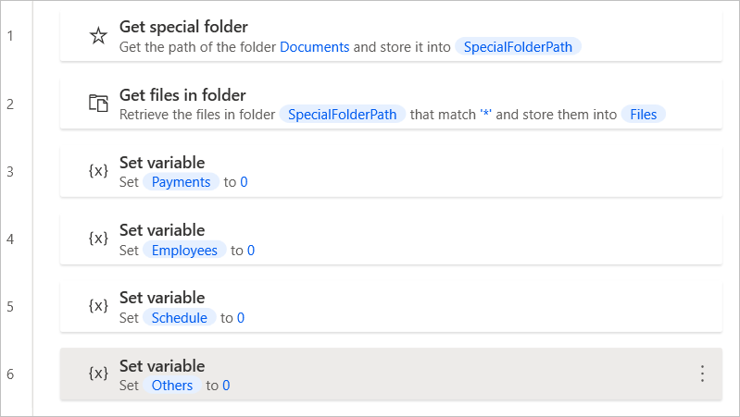

Because the files located in the Documents folder are stored in a list, we will use a **For Each** loop to iterate through each file:

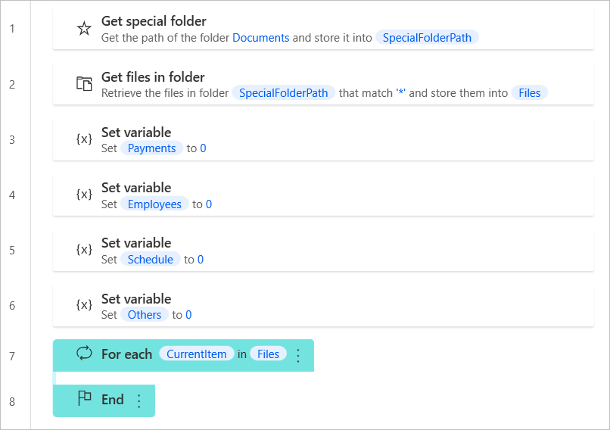

Now, we need to check each file for the required keywords. To achieve this, we will use a **Switch** action:

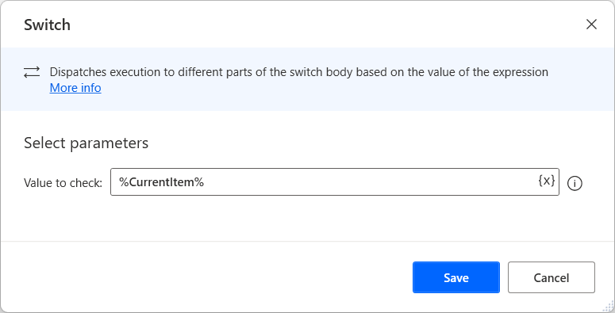

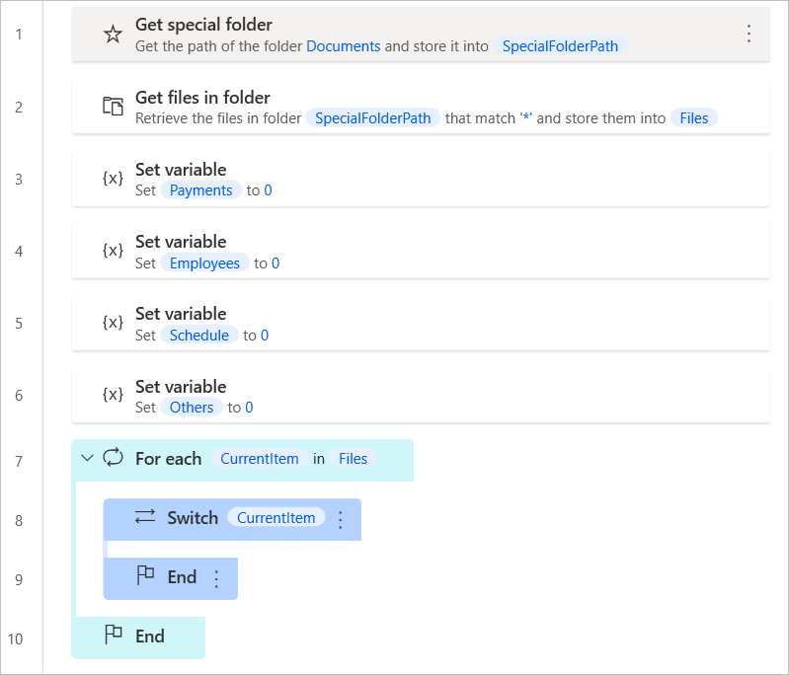

Next, we will add the alternative cases, using **Case** actions. The **Contains** comparison is used, since filenames may contain more characters than our keywords:

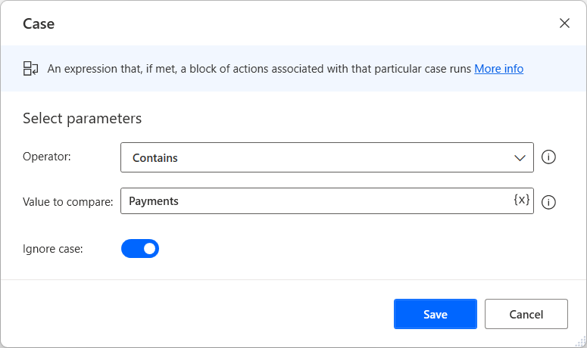

Eventually, the flow should look like this:

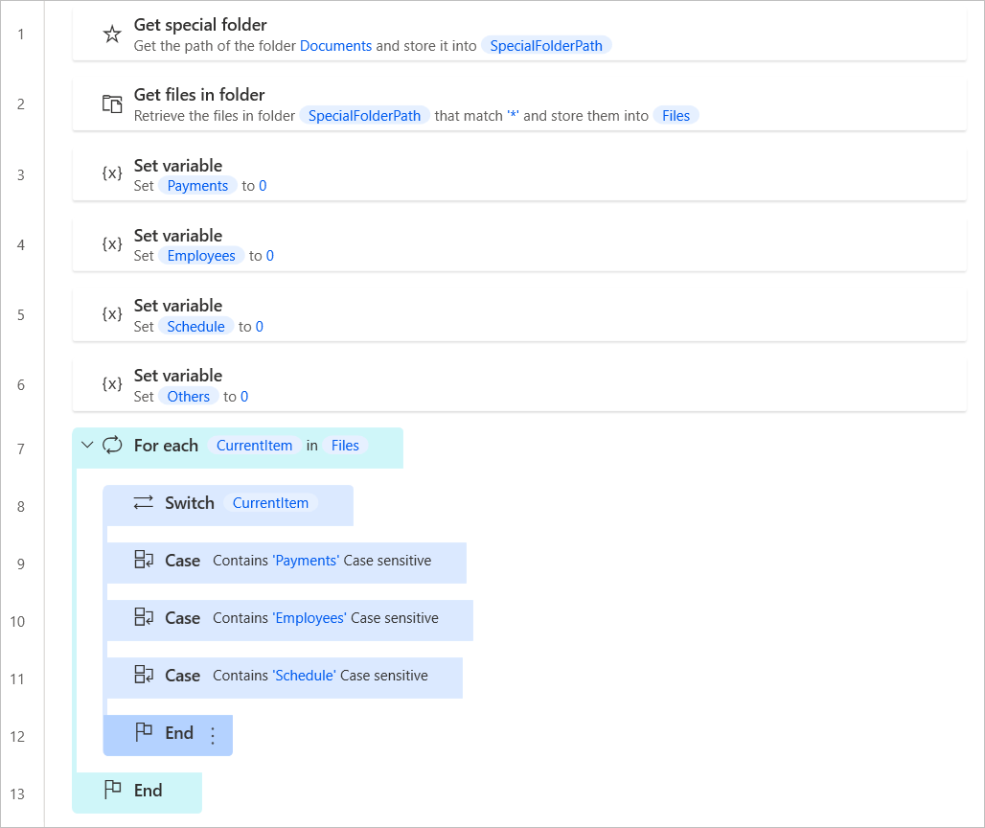

We will also add an unconditional alternative, in case some files contain none of our keywords:



Inside each case, we will increase the respective counter variable; finally, we will add a message box to be displayed:

